

LAB 03

**Table of Contents:**

1. Default Constructor
2. Parametrized Constructor
3. Copy Constructor

**1. Default Constructor**

**Definition**

A default constructor is a special member function that is automatically called when an object of a class is created. It has no parameters and is typically used to initialize member variables to default values.

**Why Use It?**

**Initialization:** Default constructors ensure that objects are properly initialized.

**Convenience:** They provide a convenient way to create objects without the need for explicit initialization values.

**Consistency:** Having a default constructor ensures that all objects of the class start with consistent initial states.

**How to Use It:**

Define a default constructor with no parameters in your class.

Inside the default constructor, initialize member variables with default values.

**Example:**

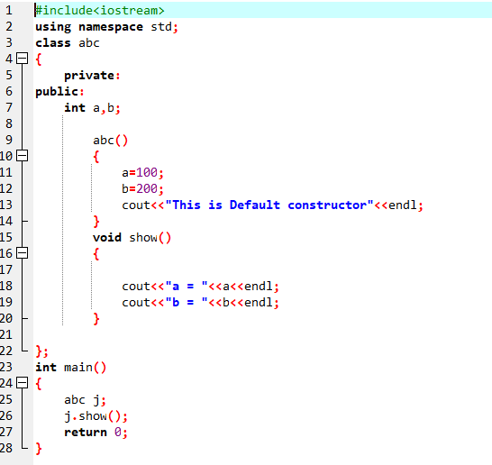

**2. Parametrized Constructor**

**Definition:**

A parametrized constructor is a member function that accepts one or more parameters, allowing you to initialize object attributes with specific values during object creation.

**Why Use It?**

Customization: Parametrized constructors enable you to customize the initial state of objects.

Flexibility: You can create objects with different initial values depending on the provided parameters.

**How to Use It:**

Define a parametrized constructor in your class.

Include parameters in the constructor to accept initialization values.

Inside the constructor, assign the parameter values to member variables.

**Example**

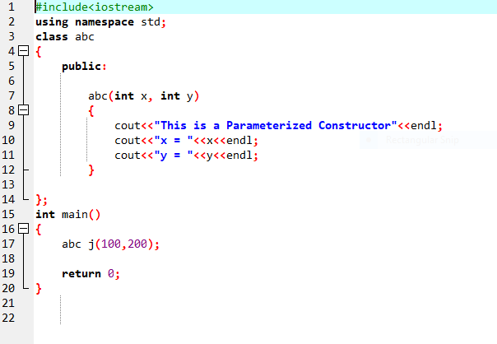

**3. Copy Constructor**

**Definition**

A copy constructor is a special constructor used to create a new object as a copy of an existing object. It is called when an object is initialized using an existing object of the same class.

**Why Use It?**

Object Duplication: Copy constructors allow you to create an identical copy of an object, useful for maintaining data integrity.

Passing by Value: It is essential when objects are passed by value to functions or returned from functions.

**How to Use It:**

Define a copy constructor in your class.

The copy constructor takes a single parameter of the same class type.

Inside the copy constructor, copy the attributes from the parameter object to the current object.

**Example**

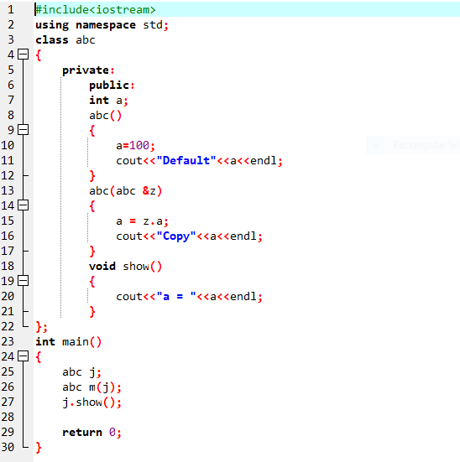

**Conclusion**

In this lab manual, we covered the key concepts of constructors in Object-Oriented Programming, including the default constructor, parametrized constructor, and copy constructor. We discussed their definitions, why they are used, and how to implement them, providing examples for better understanding. Constructors are essential in OOP to ensure proper initialization and object manipulation.

**Task No 01:**

**Objective**

The objective of this assignment is to practice implementing and using different types of constructors in an Object-Oriented Programming (OOP) context. You will create a Student class with three constructors: default constructor, parametrized constructor, and copy constructor, to manage student information.

**Instructions**

**Part 1:** Create the Student Class.

Create a C++ class named Student with the following private member variables:

Name (string): to store the student's name.

RollNumber (int): to store the student's roll number.

UniversityName (string): to store the university's name.

ClassName (string): to store the class name.

Implement the following constructors within the Student class:

Default Constructor: This constructor should initialize all member variables with default values (e.g., empty strings for names and zero for roll number).

Parametrized Constructor: This constructor should accept values for all four member variables and initialize them accordingly.

Copy Constructor: Implement a copy constructor to create a copy of an existing Student object. This should also display a message indicating that the copy constructor was called.

Create a member function DisplayInfo that displays the student's information (name, roll number, university name, and class name).

**Part 2:** Main Program

In the main program, create two instances of the Student class:

One using the default constructor.

Another using the parametrized constructor with sample values.

Create a third instance by copying the second instance using the copy constructor.

Display the information for all three instances using the DisplayInfo function.

Ensure that you demonstrate the use of constructors, proper object initialization, and copying an object with the copy constructor.